"Hello, my name is Saffron Weale I am Elijah Oyefeso’s personal assistant, head of marketing and also I provide signals to members of DCT. This document is going to help you market."

First of all, what service do DCT provide?

It is important when approaching a new customer that you know what you are talking about because the majority of customers that you will talk to will not know anything about trading, so it is your job to persuade them to why they should sign up with DCT. Please read the information below properly. You need to pick and choose what information you think will be useful in marketing. Remember every single customer is different, so you need to talk to them in a way that is appropriate to them.

So let me explain....
DCT specialise in binary trading. Meaning that we invest on a forecast of whether an asset rises or falls within a certain period of time.
Okay in simple terms this just means that Elijah predicts what happens in the market whether something is going to go up or down: e.g. oil is going to go up.

Now these predictions are called trading signals.
Signals are calculated predictions produced from our own analysis of the markets, which is then sent to the customer via WhatsApp.
So Elijah predicts what happens in the market then sends these predictions to the customer.
This customer receives the signals and makes these trades.

To sum up what our service is:

- ELIJAH PREDICTS WHAT HAPPENS IN THE MARKET

- HE THEN SENDS THIS TO HIS CUSTOMERS ON WHATSAPP

- CUSTOMERS THEN MAKE THE TRADES AND MAKE THEIR MONEY

More information about the signals:

- DCT offer a 6 week free trial for signals.
- DCT send around 7-11 signals per day, Monday to Friday.
- The average success rate of DCT signals is 73.3%.
- Pay outs/ profit is around 82%. So say a customer puts £100 they will get back £182… another example say they put £20 they will get £37 back.
- The client keeps all of the profits that they make from the signal.
- They client will get a six week free trial of signals. After that it cost £107, its their choice if they want to continue.

What you need to do:

- Inform customer what our service is. (you have all this information above)
- Get them to sign up to a platform (this link will be provided) (a platform is what the customer will trade on)
- When signing up to the platform they need to deposit $250-$300 (which is roughly £200 converted to the British pound) minimum into the platform they have just signed up to. (If they want to deposit more than $250/300 great!)
- When they have signed up get them to send a screen shot of this deposit; send their full name; their email address and number for WhatsApp to you.
- When they have sent you this information send this to me via WhatsApp. You have to send me the picture of the deposit in order to get paid.
- Send them the tutorial link of how to use the signals and then get them to pop up to me with their full name on 07534000210 in order to receive signals and I will take it from there!

*Customers have to use the links that we give, they cannot use their own platform*
*If you have any problems with customers saying that you are a fake account ect, give them my number I will talk to them*
* Signals Video tutorial: https://youtu.be/p3R7yab2Pk8*

Pay:

- The amount you get paid does differ.
- To start with you will get £35 for the first 5 clients you get. After that you will get £45-£50 per client. This will be discussed further.
- Every week you will be given a target, so say the target is to get 25 clients that week and for example you get paid £45 per client, you will make £1,125. On top of your pay because you reached your goal you get bonuses that range from £300-£2,000, depending on how much you exceed your goal.
- When you get a client, you will receive money in your account that evening.

(These are not fixed amounts of pay they can increase, but this will be discussed in further detail with myself)

Example of what you will be doing (conversation between customer and yourself):

YOU: "Hi would you like to start trading with DCT we have a six week trial on offer!"
(in this case the customer has popped up to me)

CUSTOMER "Great. How do I get started"

YOU: "Sign up to this link, this is what you will trade on. You need to deposit $250, this is the money you will trade with"
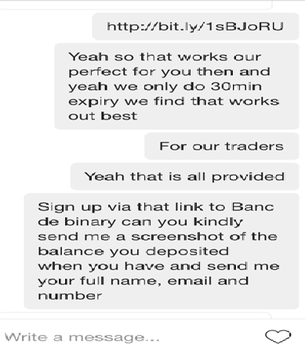

CUSTOMER: "Great I have signed up and deposited"

YOU: "Please send me a picture of your deposit, full name, email and number"

CUSTOMER: " *picture of deposit", Smith Johnson, johnson@gmail.com, 07856111856 "
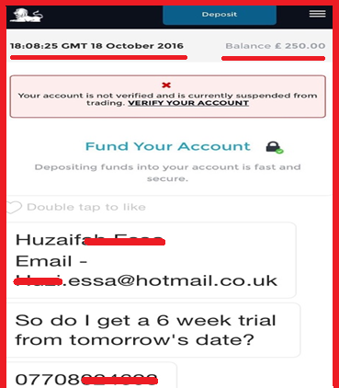
(forward this information on to me: picture of deposit, full name, email and number. I will then pay you)

YOU: "Here's the tutorial video. Welcome to our team. Please WhatsApp Saffron: 07534000210, pop up with your full name. You will receive signals from her"

Now you know what you will be marketing on. There is only a few more bits of information that you need to know

If you need help to start up you social media account:

Examples of what you can market on:
- Facebook
- Instagram
- Twitter
- Snapchat

If you have any other methods that is great! If you need help setting up this account please message me on WhatsApp and I can help you.
If you already have any of these accounts you can use your own social media page to market on.

What will you upload on your social media account?
On whatsapp I will send you through pictures to upload all the time. You can pick and choose which ones you like. I will also send you the links to the platforms, they change all the time but I will update you when they change.

To help you market:
You can go on the internet to buy followers and likes. For example for Instagram:
https://smmpoint.com/buy-instagram-followers/
(type in Google smmpoint buy followers on Instagram)
They are very cheap. Other social media sites will have the same websites available for you to do this.

Tips on how to get customers:
- Frequently upload pictures, make sure the descriptions in the photo you upload are meaningful. Be more relaxed, make people want to look at the post. Do not write captions like : "dm to make money". An example of what the posts should look like:

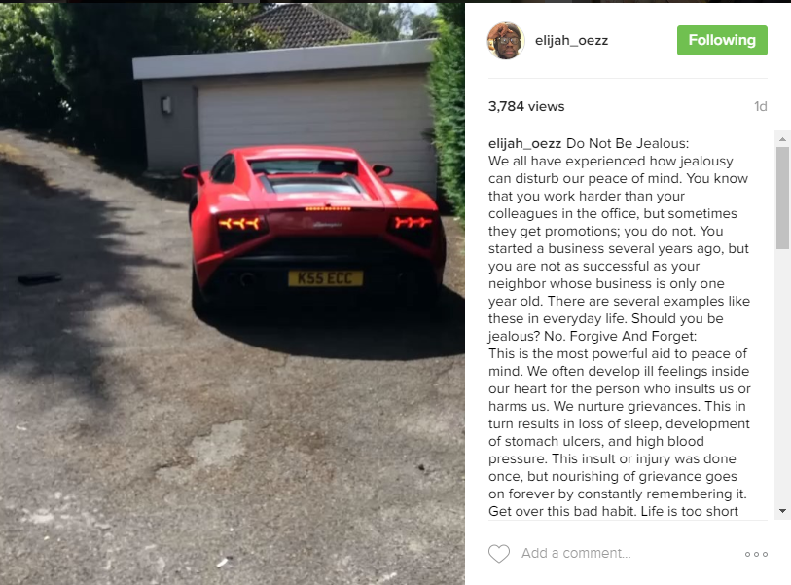
- Follow people on a regular basis. This is so important because say you follow 100 people around the world, you are going to get someone who is going to sign up. A way of following the right people is maybe clicking onto a designer shoe page, follow their followers. Following people is the most key aspect to marketing.
- Message people frequently. Messaging people is important. On the next page I explain different ways on how to talk to people. You need to be messaging more than 30 people a day.
- Speak to them on the phone. Some customers will not be comfortable signing up to something on the internet, hearing someone's voice gives the customer reassurance.

Pitch to help you:

Opening Messages

- Hi bro, I have spaces on my trading team if you were looking to get into investing. Same day profits on successful trades, basics will be taught etc..

- Hi, are you interested in learning the basics of trading or earning a 2nd income?

- Hello, how are you? If you are interested in trading there are a few spaces available on my team…

- Hi, just wondering what you do for a living atm, I work with Elijah Oyefesos trading team (you may of seen him on channel 4)! We have a few spaces on the team if you’re interested in making extra income through market trading?

How do I get started?

- All you need is some initial capital to trade with ( I recommend starting small to begin with as you can still make decent profits) and a trading account with one of our partnered brokers/ apps. Takes literally 60 seconds to sign up…

- After that I’ll add you to the signals so you’ll receive Elijah’s personal trading signals 5 days a week.. around 7-11 a day. You’ll be added to the signals group and we can send a video tutorial on how to follow signals.. it’s really simple and not time consuming at all.

Send the link, tell them it takes 30 seconds.. after they sign up send the video tutorial for signals so they understand how simple it is.

Signals Video tutorial: https://youtu.be/p3R7yab2Pk8

How much do I have to start with

- Most people usually start between £250 - £1000, that’s a great starting point if you’re looking to make decent profits to begin with. I recommend the small end of that. You only trade with a tiny % of it each day and you have complete control of it. If you want to start in less you can trade in $, $250 is around £190… but working in £ will get you more profit back for each successful trade.

- After they deposit you need to ask for a screenshot, and detail..... Excellent, I just need you to send me a screenshot of your balance as proof of investment. Also can you send your full name, email and number so I can forward it on to the team and have you added for the next signals.

- After they send proof of investment and their info…

- Hi, perfect, that's all sorted. To speed things up please whatsapp +447534000210 with your full name so they can send you a video tutorial with more info on how to use signals, please watch it as it will help. Please save the number and allow some time for them to send it over as they have to process all new traders. If you have any problems or you need me to go over anything with you, just let me know. Welcome to the team! (p.s we are much busier than usual so please be patient with awaiting a response, it may take 2 or 3 days to have you added, please be patient, you will be trading with us very shortly) (Also markets are closed on weekends) If you have any issues let me know
More info that you may need to use:
We provide trading signals (calculated predictions produced from our own analysis of the markets) telling new traders like yourself, which trades to make and when to actually make them. All you do is follow along and make profits when us experienced traders do. We send around 10 of these through the day. You keep all of the profits you make. We average 73.3% so we’re very consistent, which you will see for yourself.

The benefit of binary trading is that you're not buying and selling, you're simply saying whether you think it will be higher or lower than what the asset currently is. So say you locked in EURUSD at 1.2485 and said it will go down, and then at the expiry time it is 1.2484, then you win. Payouts are around 82% so if you put £100 on it, you get £182 back. If you put £20 on you get like £37 back. So a very simple concept combined with our technical analysis and money management strategies, we manage to do a very good job, and turn nice weekly profits.

The minimum deposit to start trading and open a trading account is $250 (£165). This is your capital and is NOT going to us. It's going in to your own trading account. It's not a payment, it’s yours to trade with and turn profit from. You need that to invest a small amount on each trade then keep multiplying it. Payout rates per successful trade average from around 70 – 85% back on what you put down. Following our signals and strategies you can grow your balance at a fast rate and then start investing higher to turn bigger profits.

